《大学英语B》复习题一
一、交际英语
1.- Take these pills three times a day. Come back and see me in a week.
- _________
A.Thank you very much indeed.
B.I can't make it.
C.I haven't decided yet.
D.Good idea!
答案：A
2.How's your family?
-- _________
A.Thanks all the same.
B.Thanks for calling.
C.Not too bad.
D.Don't mention it.
答案：C
3.- This box is too heavy for me to carry it upstairs.
- _______
A.You may ask for help.
B.I'll give you a hand.
C.Please do me a favor.
D.I'd come to help.
答案：B
4.I didn't mean to do that. Please forgive me.
-- _________
A.Not too bad.
B.That's all right.
C.It's a pleasure.
D.Thank you.
答案：B
5.Good morning, may I speak to Mark, please?
-- _________
A.Who's there?
B.Who's that speaking?
C.Who are you?
D.Who wants to speak to Mark?
答案：B
二、阅读理解
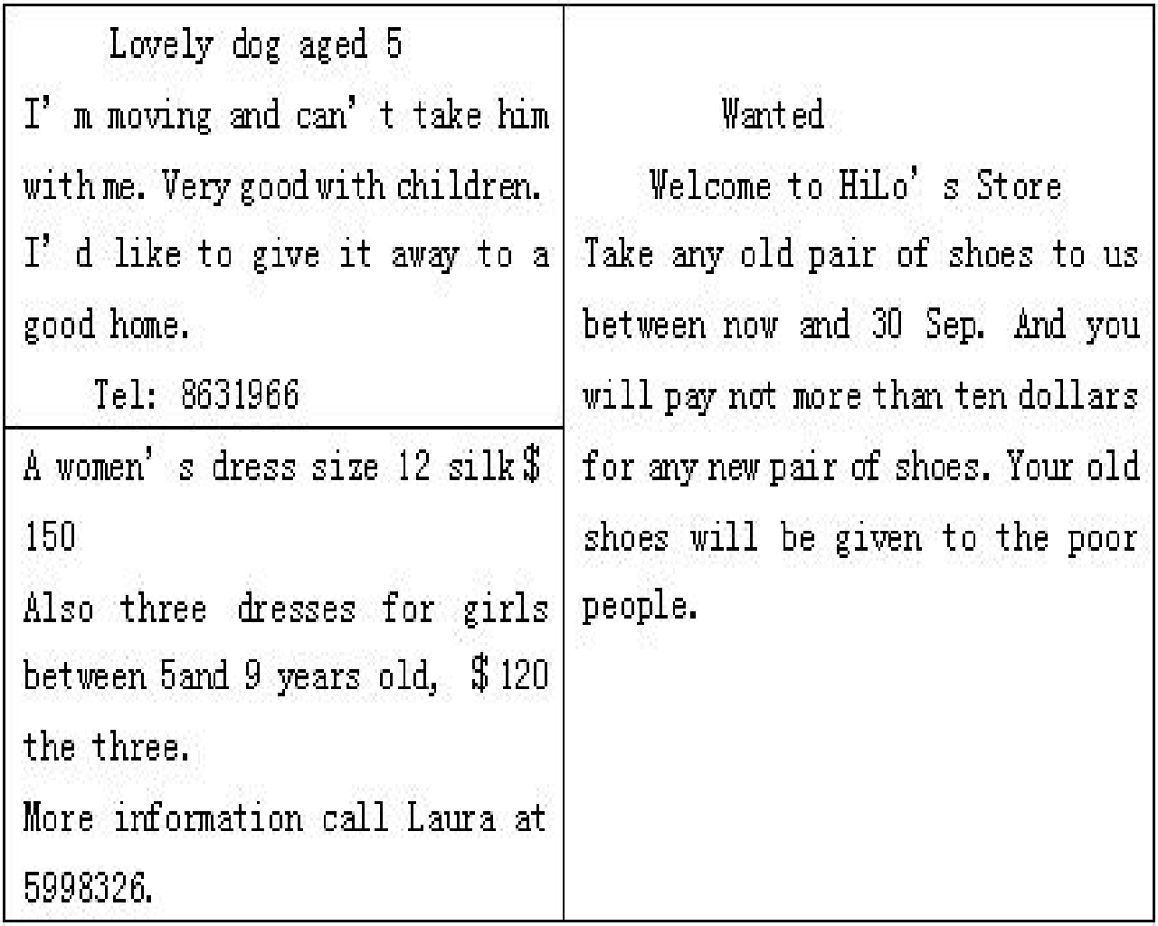
6.If Mrs Evans is interested in the dresses, she may call 5998326.
A.T
B.F
答案：A
7.You needn't pay if you want to get a lovely dog.
A.T
B.F
答案：A
8.If Mrs Evans wants to buy all the dresses, she has to pay ＄270.
A.T
B.F
答案：A
9.If you give an old pair of shoes to HiLo's Store, you can get anynew pair of shoes with only 10 dollars.
A.T
B.F
答案：B
10.The old shoes will be given to beggars.
A.T
B.F
答案：B
How men first learnt to invent words is unknown; in other words, the origin of language is a mystery. All we really know is that men, unlike animals, somehow invented certain sounds to express thought and feelings, actions and things, so that they could communicate with each other; and that later they agreed upon certain signs, called letters, which could be combined to present those sounds, and which could be written down. Those sounds, whether spoken or written in letters, we call words.
The power of words, then, lies in their associations - the things they bring up before our minds. Words become filled with meaning for us by experience; and the longer we live, the more certain words recall to us the glad and sad events of our past; and the more we read and learn, the more the number of words that mean something increases.
Great writers are those who not only have great thoughts but also express these thoughts in words which appeal powerfully to our minds and emotions. This charming and telling use of words is what we call literary style. Above all, the real poet is a master of words. He can convey his meaning in words which sing like music and which by their position and association can move men to tears. We should therefore learn to choose our words carefully and use them accurately, or they will make our speech silly and vulgar.
11.The origin of language is _________.
A.a legend handed down from the past
B.a matter that is hidden or secret
C.a question difficult to answer
D.a problem not yet solved
答案：D
12.What is true about words?
A.They are used to express feelings only.
B.They can not be written down.
C.They are simply sounds.
D.They are mysterious.
答案：C
13.The real power of words consists in their ______.
A.properties
B.characteristics
C.peculiarity
D.representative function
答案：D
14.By “association” in the last paragraph, the author means ______.
A.a special quality
B.a joining of ideas in the mind
C.an appearance which is puzzling
D.a strange feature
答案：B
15.Which of the following statements about the real poet is NOT true?
A.He is no more than a master of words.
B.He can convey his ideas in words which sing like music.
C.He can move men to tears.
D.His style is always charming.
答案：A
三、词汇与语法
16.The Japanese, ______ average, live much longer than the Europeans.
A.with
B.in
C.to
D.on
答案：D
17.Look! Here _______ the famous player.
A.comes
B.come
C.had come
D.coming
答案：A
18.______ the War of Independence, the United States was an English colony.
A.Before
B.At
C.In
D.Between
答案：A
19.Eggs, though rich in nourishments, have ______ of fat.
A.a large number
B.the large number
C.a large amount
D.the large amount
答案：C
20.The computer system ________ suddenly while he was searching for information on the Internet.
A.broke down
B.broke out
C.broke up
D.broke in
答案：A
四、完型填空
Mr. Clarke works in a middle school. He likes reading and often borrows some books from the library. He keeps ___21___ to the radio every morning and reading newspapers after supper. So he knows much and teaches well. His students worship（崇拜）him very much.
Mike, Mr. Clarke's little son, is only nine. He ___22___ likes reading books. And he often asks his father some qusetions. Mr. Clarke always thinks he's too ___23___ to understand him and chooses the easiest ones to answer. Of course the boy is not pleased with that.
One day Mike read ___24___ about the lights and was interested in it. When his father told him to do some housework, he went on thinking of it. He asked him ___25___ questions, and his father answered all. Then his father said proudly, "Fathers always know more than sons!"
The boy thought for a while and said, "I don't think so!"
21.
A.a few
B.listening
C.also
D.young
E.something
答案：B
22.
A.a few
B.listening
C.also
D.young
E.something
答案：C
23.
A.a few
B.listening
C.also
D.young
E.something
答案：D
24.
A.a few
B.listening
C.also
D.young
E.something
答案：E
25.
A.a few
B.listening
C.also
D.young
E.something
答案：A
五、英译汉
26.I could hardly agree to what you said just now.
答案：我不能同意你刚才说的话。
27.There is only some old furniture in the room.
答案：这间房里布置了几件旧家具。
28.You must always remember not to cheat in exams.
答案：你们必须记住永远都不要在考试时作弊。
29.Do you have access to the Internet?
答案：你能上网吗？
30.I knocked on his door but nobody came to answer it.
答案：我敲了他的门，但没人来开门。
31.I would appreciate it if you would just let me deal with this case.
答案：如果你能让我独自处理这桩案件，我将不胜感激。
六、写作
32.写作
Instructions:根据下面所给的题目和提纲用英语写出一篇不少于80词的短文。
An Unforgettable Experience
1.介绍你的一次经历；
2.为什么那次经历令你难忘。
答案：无

